# Microwave propagation and absorption and its thermo-mechanical consequences in heterogeneous rocks

Lead to diffuse scattering with up to 20 percent changes of the intensity in the main beam compared to a homogeneous model rock.

Strong selective heating.

Assumption is that the matrix does not absorb microwave energy.

In rocks with strong heterogeneity, even for a smooth distribution of microwave field and the temperature, stresses can have short-range variations due to the different thermal expansion of the constituents.

In further investigations the actual microstructure and orientation of the grains will be taken into account in order to obtain a deeper understanding of the stress distribution.

2.45 GHz, wavelength for *κr* = 7 is approximately 5 cm. the size of the computational domain is 50 · 32 cm2. The [computational grid](https://www-sciencedirect-com.ezproxy.lib.monash.edu.au/topics/earth-and-planetary-sciences/computational-grid) has a lattice constant of 0.05 cm (20 pixels/cell).

The microwave source with width 8.6 cm (corresponding to the opening of the [waveguide](https://www-sciencedirect-com.ezproxy.lib.monash.edu.au/topics/earth-and-planetary-sciences/waveguide) for 2.45 GHz)

# Application of numerical modelling for prediction of the influence of power density on microwave-assisted breakage-2003

They investigate the influence of microwave heating on the reduction of rock strength.

There are some good data to base simulation upon, such as:

The dielectric loss factor, εr″, for pyrite has been found to be dependent on temperature (Salsman et al., 1996). In determining the power density for the pyrite, the relationship between εr″ and temperature as shown in Fig. 2 was utilised (Salsman et al., 1996).

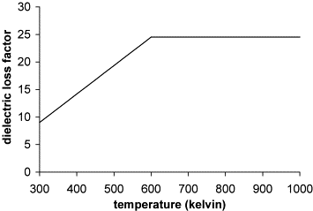

2.6-kW, 2.45-GHz multimode microwave cavity:

The calculated power density varied between **3×109 W/m3** at 300 K and **9×109 W/m3** for temperatures greater than 600 K (Fig. 3) (Kingman, 1998)

## Stage 4. Modelling of thermal damage associated with material failure and strain softening

modelling of brittle fracture and subsequent post failure strain softening, which is characteristic of the stress–strain relationship of a crystalline limestone (Hoek and Brown, 1980), The strength of the ore was approximated as a very strong brittle crystalline limestone with an unconfined compressive strength of **125 MPa** and a shear strength related by a linear Mohr–Coulomb strength criterion (Eq. (10)).



Upon failure, the ore was assumed to behave as a brittle linear strain softening medium undergoing plastic deformation with a final residual strength being obtained after 1% strain again characteristic of a strong crystalline limestone [(Hoek and Brown, 1980)](https://www-sciencedirect-com.ezproxy.lib.monash.edu.au/science/article/pii/S0301751602000492#BIB17) [(Table 4)](https://www-sciencedirect-com.ezproxy.lib.monash.edu.au/science/article/pii/S0301751602000492#TBL4).

## Stage 5. Simulations of the unconfined compressive strength tests on the thermally damaged samples

The simulation was undertaken by applying a constant velocity to the grid points positioned at the top and base of the model domain whilst the left and right boundaries were unstrained. This is analogous to a displacement-controlled uniaxial compressive strength test. The models were run until approximately 0.2% axial strain of the sample whereupon the models predicted failure strength and some strain softening details of the samples was obtained.

# A review of discrete modelling techniques for fracturing processes in discontinuous rock masses

# Grain-Based Discrete Element Method (GB-DEM) Modelling of Multi-scale Fracturing in Rocks Under Dynamic Loading

# Understanding microwave-assisted breakage

A very good article on rock particle fracturing.

# 

# The Effect of Particle Size Distribution on Packing Density

Powders with a wider size range havc a lower porosity than those with a similar form of distribution but having narrower size limits.

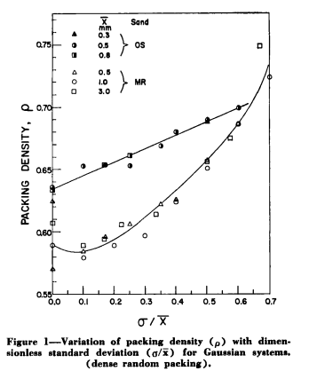

More linear cutting tests on rock blocks kerfed by novel/mechanical methods need to be conducted for a more comprehensive comparison

Two well defined types of size distribution were used, viz. Gaussian and log-normal, by weight.

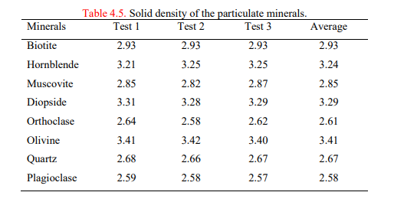

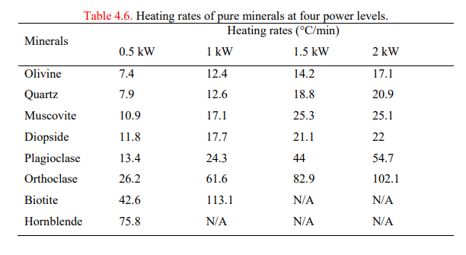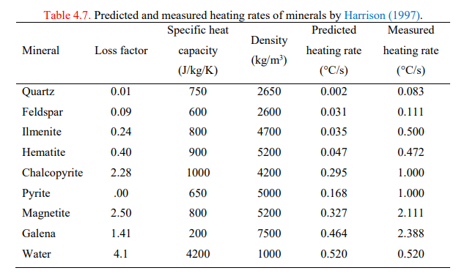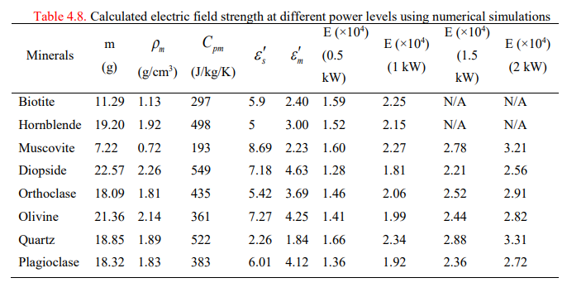

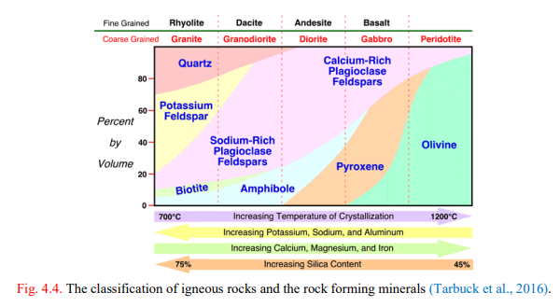

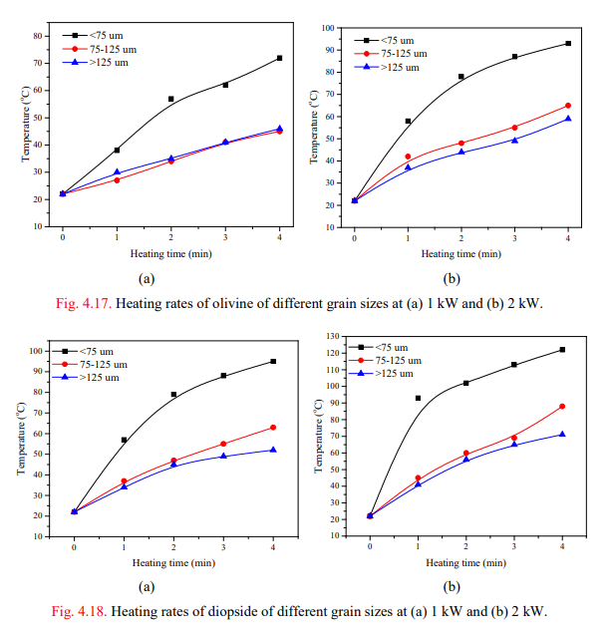

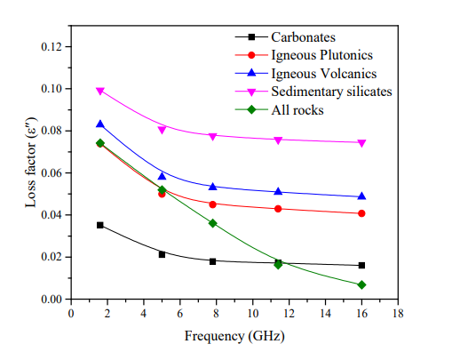

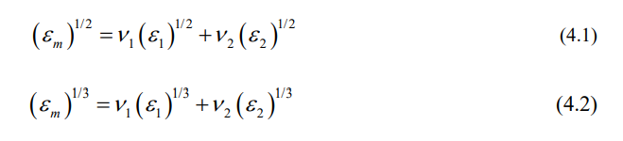

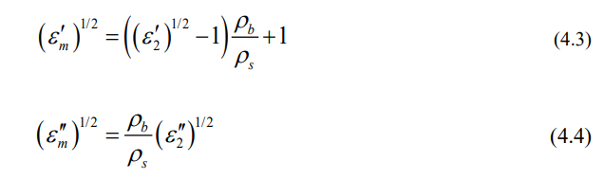

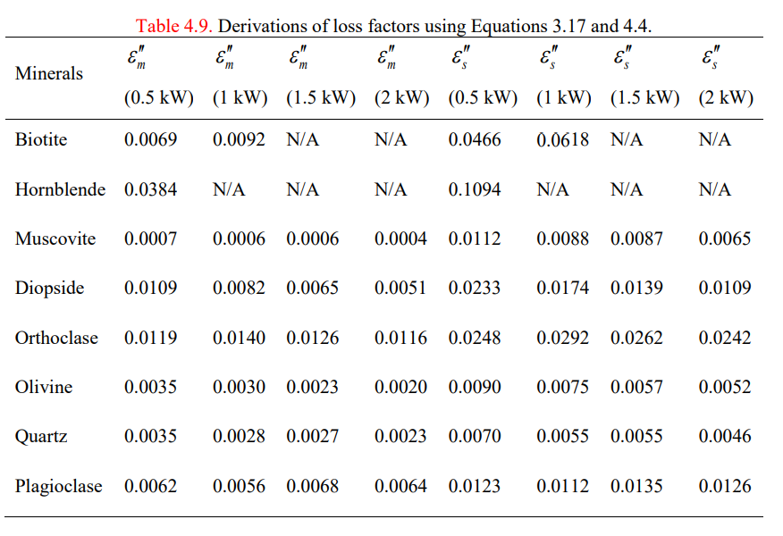

Effects of microwae heating on ore sorting

